**WEEK 5 HANDSON**

**HandsOn TASK 2 :**

Create a react app for Student Management Portal named StudentApp and create a component named Home which will display the Message “Welcome to the Home page of Student Management Portal”. Create another component named About and display the Message “Welcome to the About page of the Student Management Portal”. Create a third component named Contact and display the Message “Welcome to the Contact page of the Student Management Portal”. Call all the three components.

**CODE AND OUTPUTS :**

1. Create a React project named “studentapp”

**npx create-react-app studentapp**

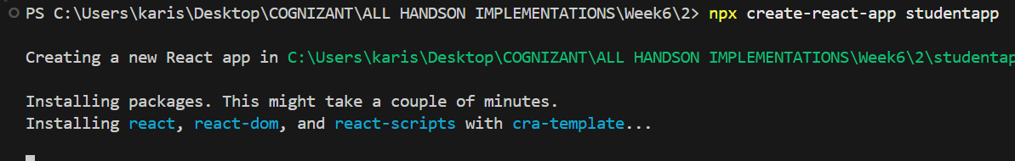

**cd studentapp > npm start**

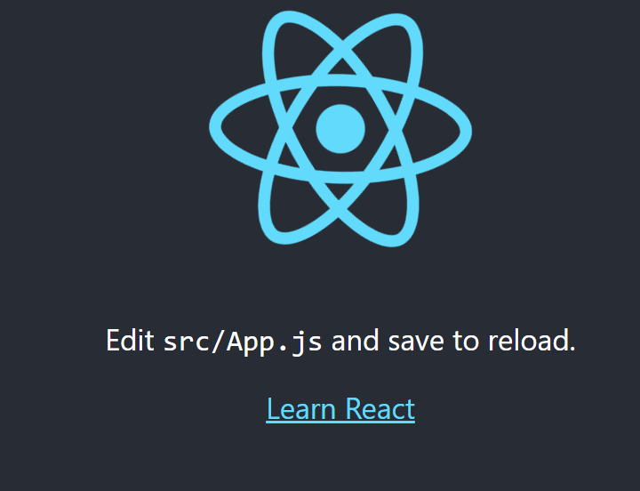

**Folder structure :**

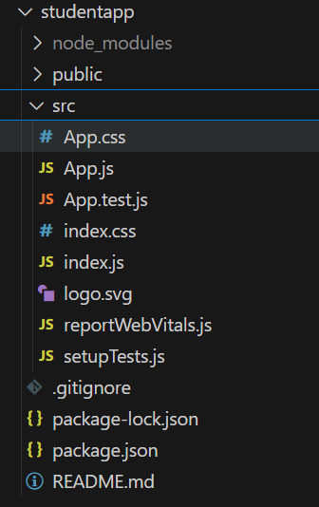

1. Create a new folder under Src folder with the name “Components”. Add a new file named “Home.js”, “About.js” , “Contact.js”.

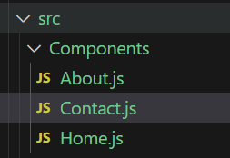

**Home.js :**

import React, { Component } from 'react';

class Home extends Component {

  render() {

    return (

      <div>

        <h3>Welcome to the Home Page of Student Management Portal</h3>

      </div>

    );

  }

}

export default Home;

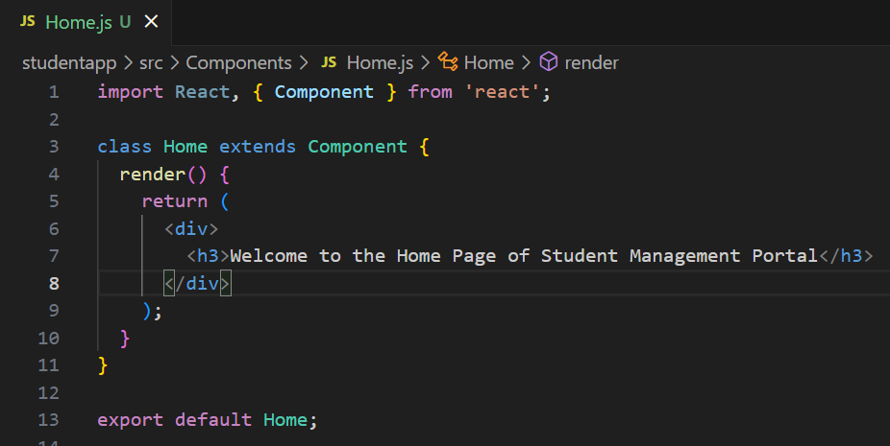

**About.js :**

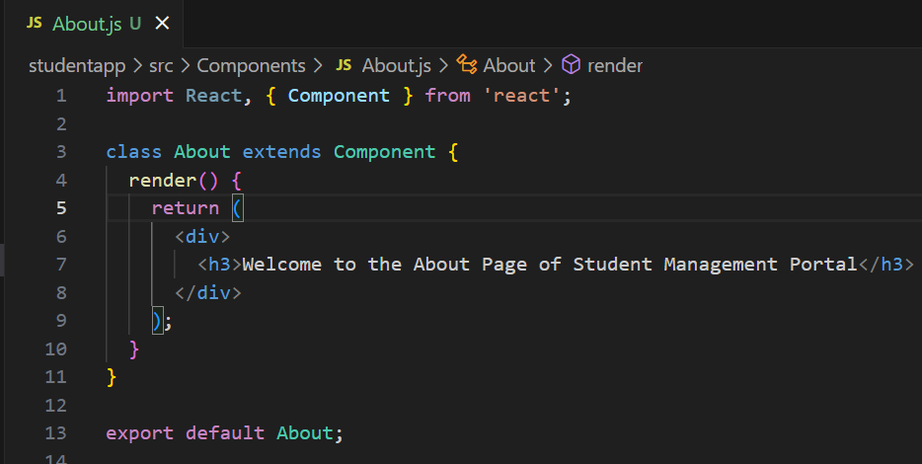

import React, { Component } from 'react';

class About extends Component {

  render() {

    return (

      <div>

        <h3>Welcome to the About Page of Student Management Portal</h3>

      </div>

    );

  }

}

export default About;

**Contact.js :**

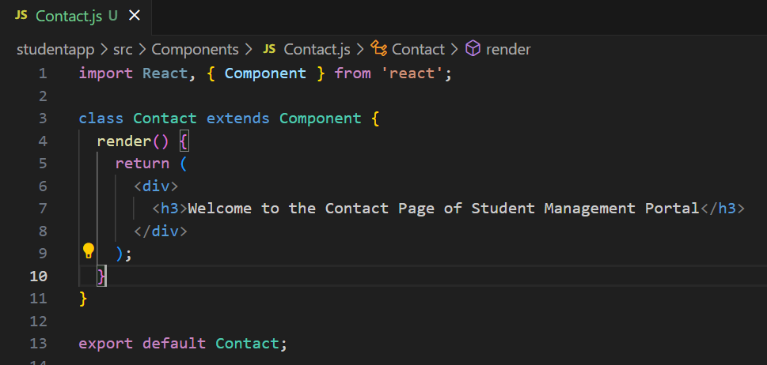

import React, { Component } from 'react';

class Contact extends Component {

  render() {

    return (

      <div>

        <h3>Welcome to the Contact Page of Student Management Portal</h3>

      </div>

    );

  }

}

export default Contact;

**3 . Edit the App.js to invoke the Home, About and Contact**

import './App.css';

import Home from './Components/Home';

import About from './Components/About';

import Contact from './Components/Contact';

function App() {

return (

<div className="container">

<Home />

<About />

<Contact />

</div>

);

}

export default App;

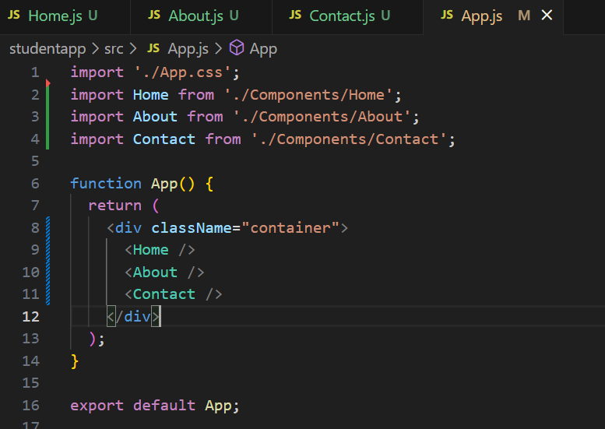

**4 . Run the react app using : npm start**

**OUTPUT :**

**-------------------**

